Input Statement to read data

When we’re writing a program, we usually don’t know
what value a variable is going to have in the program
because we’re probably going to calculate a value for it
or obtain the value from outside of the program.
So in addition to using an assignment statement to put
a value into a variable, the program can also assign a
value to a variable by asking the user of the program to
enter the value to be assigned (reading the value).

Reading from the keyboard uses the input operator >>.
The name cin is used to indicate the keyboard is the
input device (cin is also referred to as “standard input”).

So a statement to read in a value for a variable x
looks like this:

cin >> x;

Rules for how C++ reads different types of values:

Starting from the current position of the cursor:
int | Skip any leading spaces or blank lines, read digits  until encountering a character that is not valid in  an integer value, like a blank space or a special  character, or a decimal point, or a letter, or the  end of the line (result of pressing Enter)
double | Skip any leading spaces or blank lines, read digits  until encountering a character that is not valid in a  floating-point value, like a blank space or a special  character other than a decimal point, or a letter, or  the end of the line.
char | Skip any leading spaces or blank lines and read the  first non-blank character encountered.
string | Skip any leading spaces or blank lines and read  characters until encountering a blank space or the  end of the line.

Example:
#include <iostream>
using namespace std;

int main ( )
{
int length;
int width;
int area;

cout << “Enter the length of a rectangle in inches: ”;
cin >> length;
cout << “Enter the width of a rectangle in inches:” << endl;
cin >> width;
area = length * width;
cout << “For a rectangle with length ” << length
<< “ and width ” << width << “,” << endl;
cout << “the area of the rectangle = ” << area
<< “ square inches” << endl;

system(“pause”);
return 0;
}

The output of this program would look like this (values entered
from the keyboard shown in bold print):

Enter the length of a rectangle in inches: 25
Enter the width of a rectangle in inches:
12
For a rectangle with length 25 and width 12,
the area of the rectangle = 300 square inches

The first two output statements:
cout << “Enter the length of a rectangle in inches: ”;
and
cout << “Enter the width of a rectangle in inches:” << endl;

are examples of prompting messages. When we want
our program to read data from the keyboard, we need to
tell the person running the program what it is our program
is waiting for. Otherwise, they just see the cursor blinking
on the black screen and they don’t know what the program
expects them to do.

When I’m reading values from the keyboard, I prefer to
prompt the user for one input value at a time. If you ask
for multiple values (like both length and width) in the same
statement, then you have to explain what kind of spacing
is required: there must be at least one blank space to
separate the two numbers.

cout << “Enter the length and width of a rectangle in inches, ”
<< endl << “leaving at least one space between the values: ”;
cin >> length;
cin >> width;

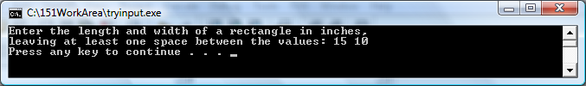

or

cout << “Enter the length and width of a rectangle in inches ”
<< “like this: 15 10” << endl;
cin >> length >> width;

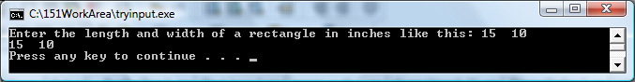

or

cout << “Enter the length and width of a rectangle in inches, ”
<< “and press Enter,” << endl;
cout << “and then enter the width of a rectangle in inches on ”
<< “the next line” << endl
<< “and press Enter again”<< endl;
cin >> length >> width;

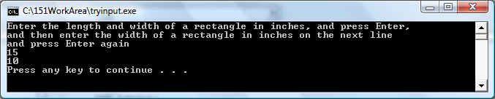

All of the input values entered by the user form one continuous
stream of data (like objects on an assembly line). Any value that
is not read by a program statement remains in the input stream
to be read by the next statement. A particular value can’t be
read until the value before it has been read.

The statement: cin >> a >> b >> c;

is the same as: cin >> a >> b;
cin >> c;

is the same as: cin >> a;
cin >> b >> c;

is the same as: cin >> a;
cin >> b;
cin >> c;

As long as the order in which successive values are read is the
same, it doesn’t matter how many statements are used.
Each occurrence of >> must be followed by an identifier which
is the variable location where we want to store the input value.

Notice that we must repeat cin in every new statement
because the semicolon ended the previous statement.

Output

Output to the screen writes to cout (also referred to as “standard output”)

cout << expression or manipulator
<< expression or manipulator . . . ;

Notice that if you want to output more than one expression in
the same cout statement, the expressions must be separated
by the << operator.

Each occurrence of << in an output statement must be
followed by something you want to print or by something you
want to tell the file manager about the output.

Generating output follows two rules:

1. The expression is evaluated and its value is printed at
the current insertion point on the output device
(where the cursor is blinking on the screen).

2. A manipulator can be used to format the output. The
only manipulator we’ve seen so far is endl which
causes the cursor (insertion point) to move to the
beginning of the next line.

You can accomplish the exact same output by writing each
individual expression or manipulator in separate statements.

Example:

Assume int variable x has a value of 25.

cout << “x = ” << x << endl
<< “and 2 times x = ” << 2 * x << endl;

produces this output:

x = 25
and 2 times x = 50

We could obtain the exact same output by coding:

cout << “x = ”;
cout << x;
cout << endl;
cout << “and 2 times x = ”;
cout << 2 * x
cout << endl;

Notice that we must repeat cout in every new statement
because the semicolon ended the previous statement.

It’s not the end of the cout statement that causes the
cursor to move from one line to another but if and where
you write the endl manipulator.

Anything following // is considered a comment and is
ignored by the compiler and is not translated – these are
explanations for people, not for the computer.

